Multiple Linear Regression

Short note about Linear Regression:

Multiple linear regressions are the most common form of the regression analysis. As a predictive analysis, multiple linear regressions are used to describe data and to explain the relationship between one dependent variable and two or more independent variables.

Decode Complex Algorithm

Step: 1

Y=a0+a1x1+a2x2

Step: 2

Normal Equation are -

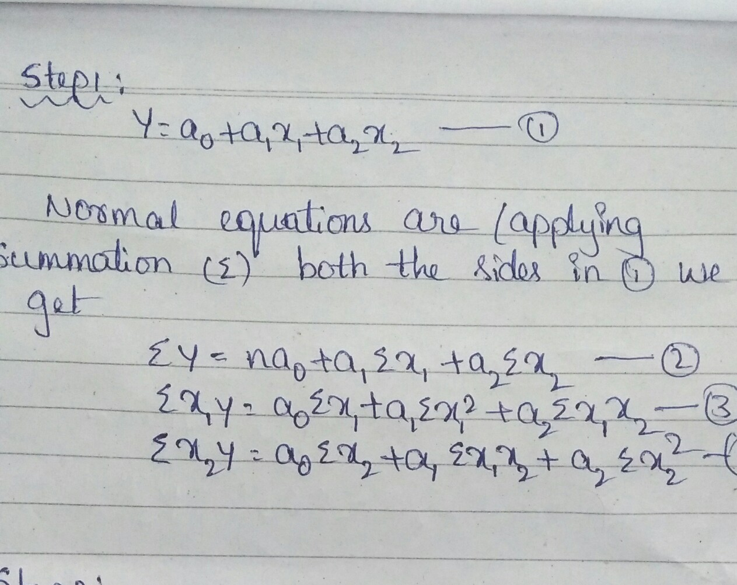

Step: 2

|  |  |  |
| --- | --- | --- |
| **x1** | **x2** | **y** |
| 1 | 10 | 12 |
| 2 | 1 | 18 |
| 3 | 2 | 24 |
| 4 | 3 | 30 |

Considered y=Roll

X1=Unemployee

X2=Hupgrade

Solving B1 & B2 [ EXAMPLE: 1]

|  |  |  |  |  |  |  |  |  |
| --- | --- | --- | --- | --- | --- | --- | --- | --- |
|  | **x1** | **x2** | **y** | **x1x2** | **x1y** | **x2y** | **x1^2** | **x2^2** |
|  | 1 | 10 | 12 | 10 | 12 | 120 | 1 | 100 |
|  | 2 | 1 | 18 | 2 | 36 | 18 | 4 | 1 |
|  | 3 | 2 | 24 | 6 | 72 | 48 | 9 | 4 |
|  | 4 | 3 | 30 | 12 | 120 | 90 | 16 | 9 |
| Total | 10 | 16 | 84 | 30 | 240 | 276 | 30 | 114 |

Step 3: Solving Multiple linear Regression using B1, B2 and a

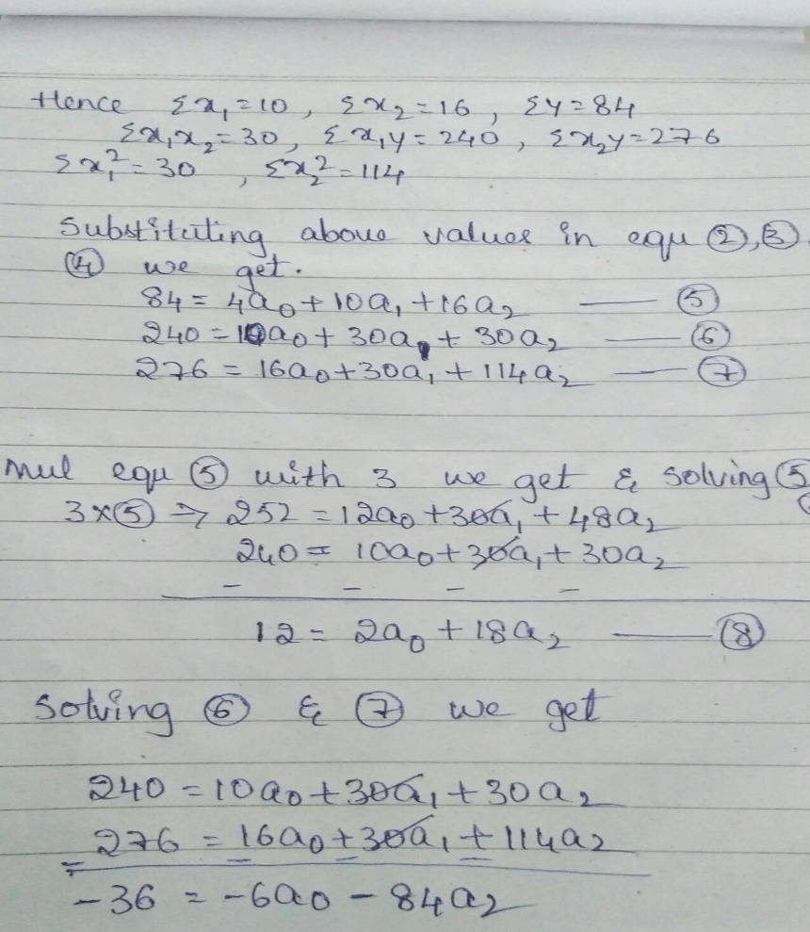

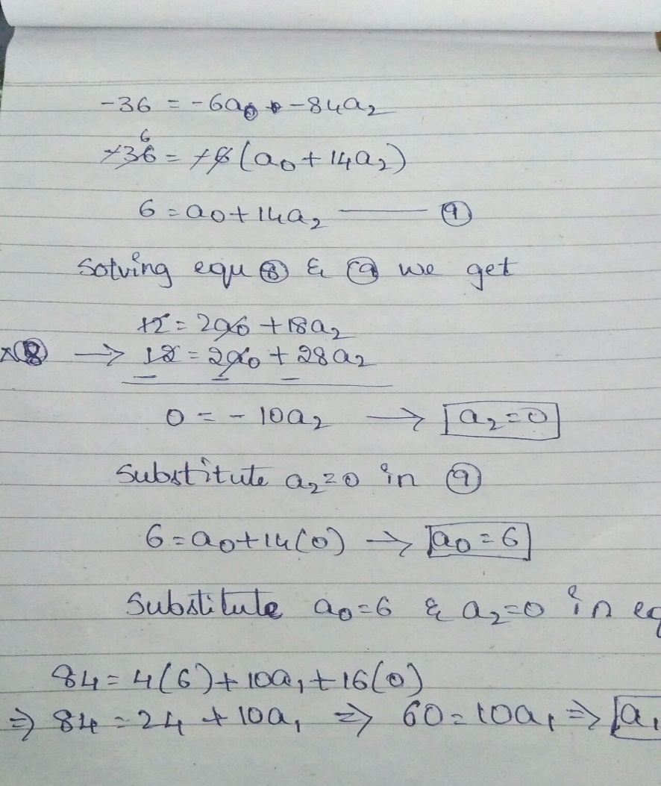

Hence a0=6,a1=6,a2=0

Substituting above values in equation1 [Y=a0+a1x1+a2x2] we get

y=6+6(x1)+0(x2)

y=6(x1)+6 is the equation of multi linear regression.

USE CASES Of Multiple Linear Regressions:

Multiple linear Regression analysis is also used to understand which among the independent variables are related to the different parameter of dependent variable.

* Finding the missing values within the given data points
* Finding the loss value using slope line

For Example

Finding housing range of different parameter

Finding chances of a person’s tobacco consumption has any association with heart disease

Finding average point score per game in basketball

Finding crime rate in cities

Finding death rate in cities

To determine if a person is worthy for loan or not.

The immunity of a child can depend on the immunity of Parents

The height of a child can depend on the height of the mother, the height of the father, nutrition, and environmental factors.

The selling price of a house can depend on the desirability of the location, the number of bedrooms, the number of bathrooms, the year the house was built, the square footage of the lot and a number of other factors.

PYTHON CODE WITHOUT LIBRARY

import pandas as pd

import numpy as np

import matplotlib.pyplot as plt

df = pd.read_csv("multivar.csv",sep='\t')

print(df.head(6))

#

X=df['Mech Apt'].values

X1=df['Consc'].values

Y=df['Job Perf'].values

n=len(X)

X_mean=np.mean(X)

X1_mean=np.mean(X1)

Y_mean=np.mean(Y)

# # X.reshape(n,-1)

# # Y.reshape(n,-1)

#

sumX=np.sum(X)

sumX1=np.sum(X1)

sumY=np.sum(Y)

#

mulXY=np.multiply(X,Y)

mulX1Y=np.multiply(X1,Y)

#

sum_mul_XY= np.sum(mulXY) # - ((sumX*sumY)/n)

sum_mul_X1Y=np.sum(mulX1Y) #- ((sumX1*sumY)/n)

#

Xsquare = np.multiply(X,X)

X1square = np.multiply(X1,X1)

Ysquare = np.multiply(Y,Y)

#

sum_X_square=np.sum(Xsquare)

sum_X1_square=np.sum(X1square)

mul_XX1 = np.multiply(X,X1)

sum_mul_XX1=np.sum(mul_XX1) #- ((sumX*sumX1)/n)

b1 = (((sum_X1_square)*(sum_mul_XY))-((sum_mul_XX1)*(sum_mul_X1Y))) / (((sum_X_square)*(sum_X1_square))-(sum_mul_XX1*sum_mul_XX1))

b2 = (((sum_X_square)*(sum_mul_X1Y))-((sum_mul_XX1)*(sum_mul_XY))) / (((sum_X_square)*(sum_X1_square)) - (sum_mul_XX1*sum_mul_XX1))

a=Y_mean-(b1*X_mean)-(b2*X1_mean)

print("sum of Y =",Y)

print("sum of X =",X)

print("x mean=",X_mean)

print("x1 mean=",X1_mean)

print("y mean=",Y_mean)

print("sum of X square =",sum_X_square)

print("sum of X1 square =",sum_X1_square)

print("sum of mul of X1*Y =",sum_mul_X1Y)

print("sum of mul of X*Y =",sum_mul_XY)

print("sum of mul of X*X1 =",sum_mul_XX1)

print("sum of mul of X*X1 square=",sum_mul_XX1*sum_mul_XX1)

print(b1)

print(b2)

print(a)

updated_y = b1*X + b2*X1 + a

PYTHON CODE WITH LIBRARY

# Encoding categorical data

from sklearn.preprocessing import LabelEncoder, OneHotEncoder

labelencoder = LabelEncoder()

X[:, 3] = labelencoder.fit_transform(X[:, 3])

onehotencoder = OneHotEncoder(categorical_features = [3])

X = onehotencoder.fit_transform(X).toarray()

# Avoiding the Dummy Variable Trap

X = X[:, 1:]

# Splitting the dataset into the Training set and Test set

from sklearn.cross_validation import train_test_split

X_train, X_test, y_train, y_test = train_test_split(X, y, test_size = 0.2, random_state = 0)

# Fitting Multiple Linear Regression to the Training set

from sklearn.linear_model import LinearRegression

regressor = LinearRegression()

regressor.fit(X_train, y_train)

# Predicting the Test set results

y_pred = regressor.predict(X_test)

Visualization

